Each card should have:
- Product Name
- 1-line description (max 12–15 words)
- Image
- Clickable

DROPDOWN PRODUCTS
- Geosynthetic Systems

Our geosynthetic systems are engineered to improve soil performance, control erosion, and enhance load distribution in civil and infrastructure projects. By reinforcing and stabilizing weak ground conditions, these solutions deliver long-term durability and cost efficiency across a wide range of applications.

  - Geocells
3D confinement systems for stabilizing weak soils and improving load distribution.
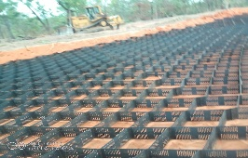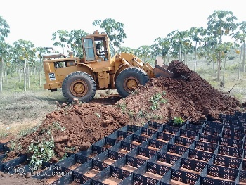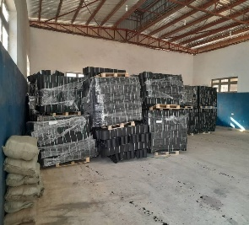
2. Geotextiles
Permeable fabrics used for separation, filtration, and drainage in soil systems.
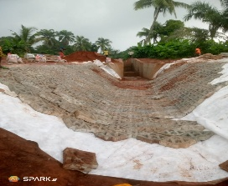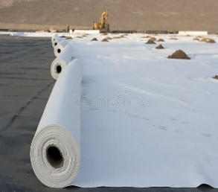
3. Grout Bags
High-strength fabric bags filled with grout to form durable, flexible concrete structures.

4. Geotubes
Large geotextile containers used for dewatering, containment, and coastal defense.
  - 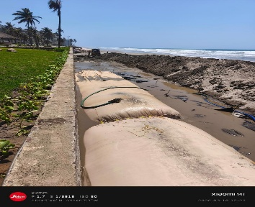

5. Geogrids
High-strength reinforcement grids that improve structural stability and load transfer.

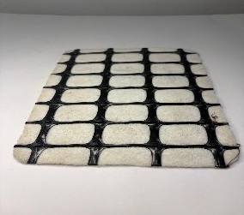
6. Geomembranes
Impermeable liners for containment, waterproofing, and environmental protection.

7. Geobags
Fabric-formed units used for erosion control and shoreline stabilization.

- Coastal & Erosion Protectio
Our coastal and erosion protection systems are designed to safeguard shorelines, riverbanks, and critical infrastructure from hydraulic forces and environmental degradation. These solutions provide robust, long-term protection against erosion, scouring, and wave impact
- Concrete Mattresses 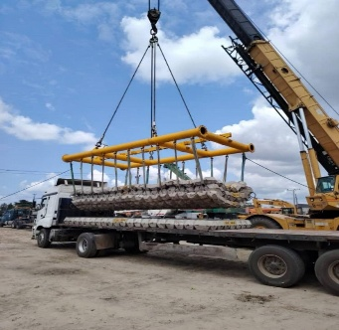
- Grout-Filled Bags - 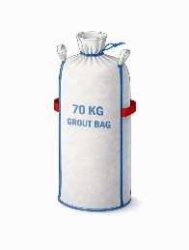 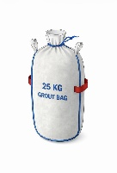 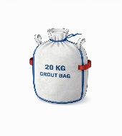
- Revetment/ACBM Systems - 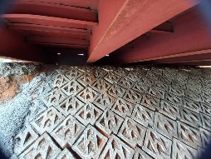 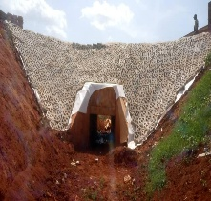  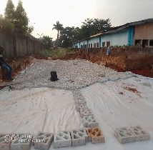 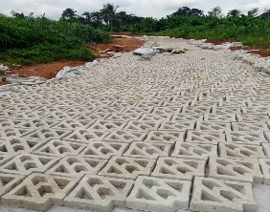
- Ground Stabilization Systems
Our ground stabilization systems are developed to improve weak or unstable soils, enabling them to safely support structural and operational loads. These solutions enhance bearing capacity, reduce settlement, and ensure reliable performance in demanding environments.
- Interlocking Concrete Systems – (See attached)
- Reinforced Paving Solutions - 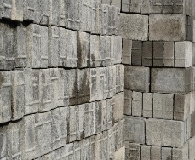
- Load Support Platforms – 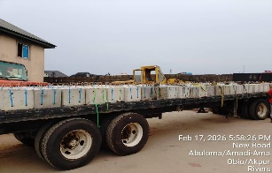 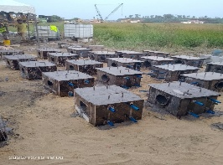

- Urban & Hardscape Systems
(we look for copyright free pictures to add here)
Our urban and hardscape systems combine structural performance with functional design to create durable and visually appealing environments. These solutions are ideal for public spaces, commercial developments, and infrastructure projects requiring both strength and aesthetics.

- Hardscape Elements
- Streetscape Solutions
- Landscape Engineering

- Anchoring Systems
- Anchoring Systems
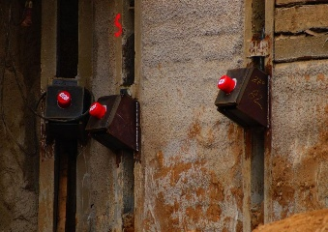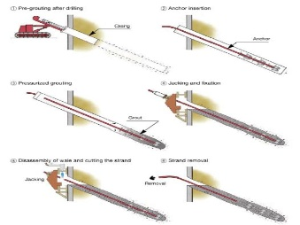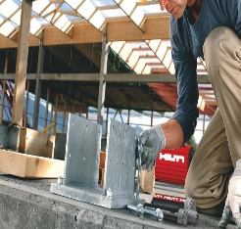

Our anchoring systems are engineered to provide stability and restraint for structures subjected to lateral and uplift forces. Designed for reliability and strength, these solutions ensure structural integrity in critical applications.
- Concrete Anchors
- Tie-Back Systems
- Custom Anchorage

- Custom Engineered Solutions

Our custom engineered solutions are developed to meet unique project requirements where standard systems are not sufficient. From specialized concrete fabrications to tailored geosynthetic applications, we deliver engineered solutions designed for performance, durability, and project-specific demands.

- Concrete Mattress (Variants) - 
- Grout Bag Systems – See attached 70kg, 25kg and 20kg bag pictures
- Bespoke Concrete Fabrications – We look for copy right free pictures to add here
- Project-Specific Designs

Display Geosynthetic Systems products as a card grid:

- 3 columns on desktop
- 2 columns on tablet
- 1 column on mobile

Order of items:
1. Geocells
2. Geotextiles
3. Grout Bags
4. Geotubes
5. Geogrids
6. Geomembranes
7. Geobags

Each card should include:
- Image
- Product name
- Short description
- Clickable link to product page

Ensure consistent spacing and alignment.

